Entertainer Data Analysis

Wireframe

Prepare by: Darshil Ashish Nanavati

Homepage

Write the procedure and new data that were added to the existing dataset in a word document.

Include the theme that you will be basing your dashboard creation on as well.

Theme: Top 10 award winners and nominees based on their Gender and Profession.

Dashboard 1

Top 10 entertainers are shown in this graph for each award i.e., Oscars, Grammy and Emmy. Here I have used SQL query to make 3 separate tables for top 10 award winners of each category and placed them in single graph. This helps in utilizing less space in the dashboard with more data visual.

This graph gives us insights about top 15 entertainers with most awards and nominations and you can see red bar shows us the sum of total awards won by and individual artist and green bar gives us information about his/her total nominations.

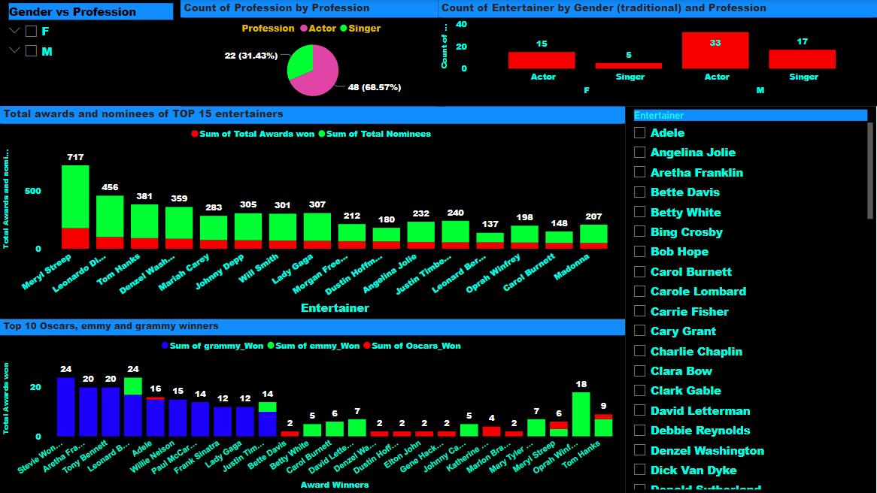

1. Here is the complete look of the dashboard where on the top left corner I have added gender vs profession slicers which will filter out all the entertainers based on their gender and profession.

2. just next to the Gender vs profession slicers we have pie chart which gives us insights into entertainer’s profession, here 68.57% of entertainers are actors and 31.43% are singers.

3. top Right corner I have added stacked column chart that gives us information about the profession of entertainers based on their Gender

4. The two stacked column chart as explained earlier gives us in-depth information about the entertainers awards and nomination.

5. Finally at the bottom right corner we have individual artists where we can filter out their individual performance.

Below are some filtered out Graphs for better understanding

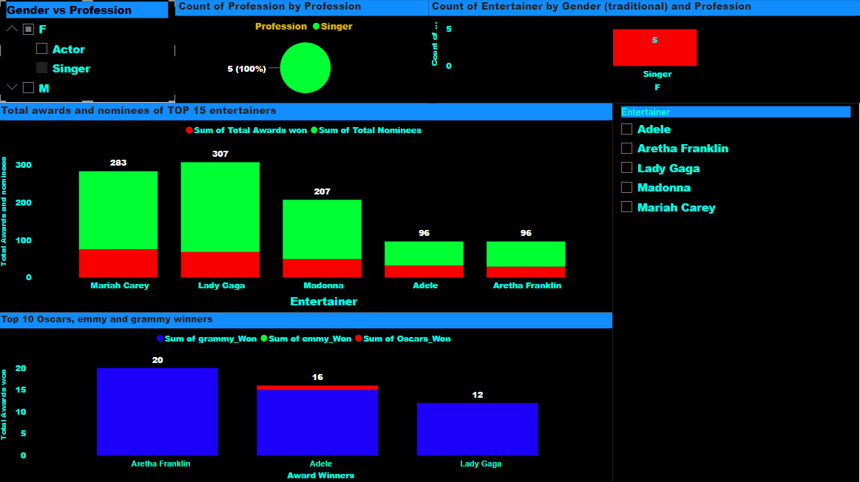

Here I have selected Female Singers as my filter this gave us information about all the singers who have won total number of awards, their nomination including all the major awards won.

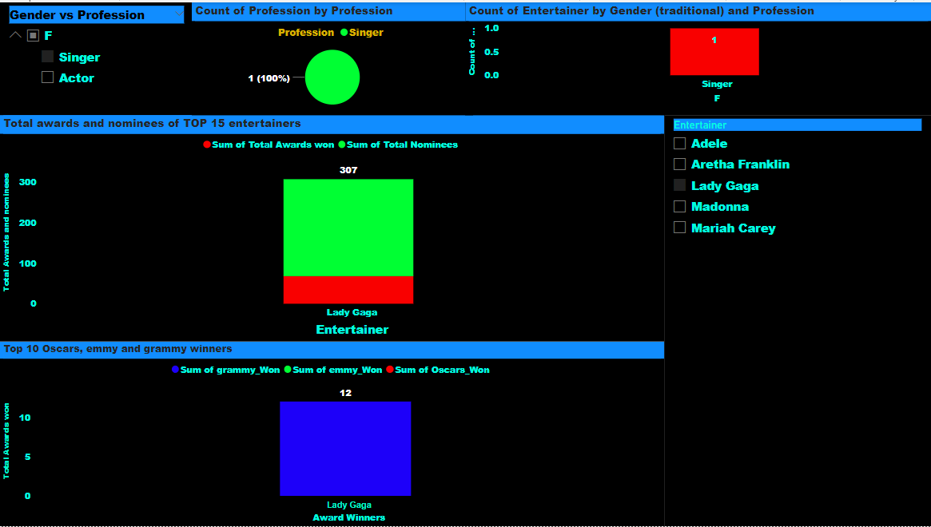

Further filtering when I selected a particular singer like lady gaga, we can see that she had total 307 nomination and awards won, but out of three major awards she has won only 16 grammy awards.